**THE PERFORMANCE OF 3 PHASE INDUCTION SQUIRREL CAGE MOTOR**

**(REPORT)**

* **INTRODUCTION OF MOTOR:**
  + A three phase squirrel cage motor is the type of three phase induction motor which functions based in the principle of electromagnetism. It is called “**Squirrel Cage**” motor because the rotor inside of it looks like squirrel cage. The rotor of this motor is a cylinder of steel laminations, with highly conductive metal embedded into its surface.
  + When an AC current is run through the stator windings. A rotating magnetic field is produced.
  + This introduces a current in the rotor winding, which produces its own magnetic field. The interaction of magnetic field produce by the stator and rotor windings produces a torque on the squirrel cage rotor.
  + Advantage of squirrel cage motor is how easily you can change its speed-torque characteristics. This can be done by simply adjusting the shape of the bars in rotor.
  + Squirrel cage induction motors are used a lot in industry as they are reliable, self-starting and easy to adjust.
* **STARTUP PROCESS:**
  + When the supply is connected to the stator of a three-phase induction motor, a rotating magnetic field is produced and the rotor of the motor begins rotating and the induction motor starts.
  + At the time of starting, the motor slip is unity, and the starting current is very large.
  + 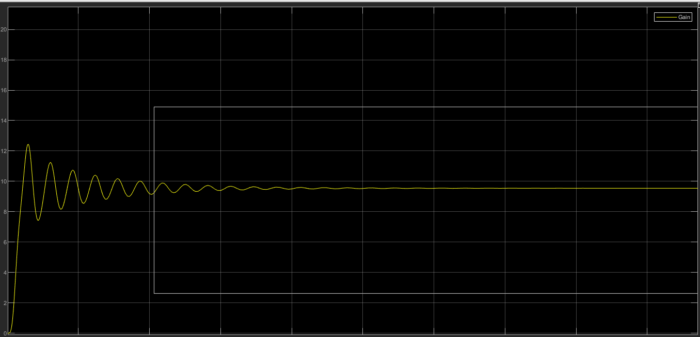
* **TERMINAL VOLTAGES:**
  + The terminal voltages for the rotor and the stator are as:
  + 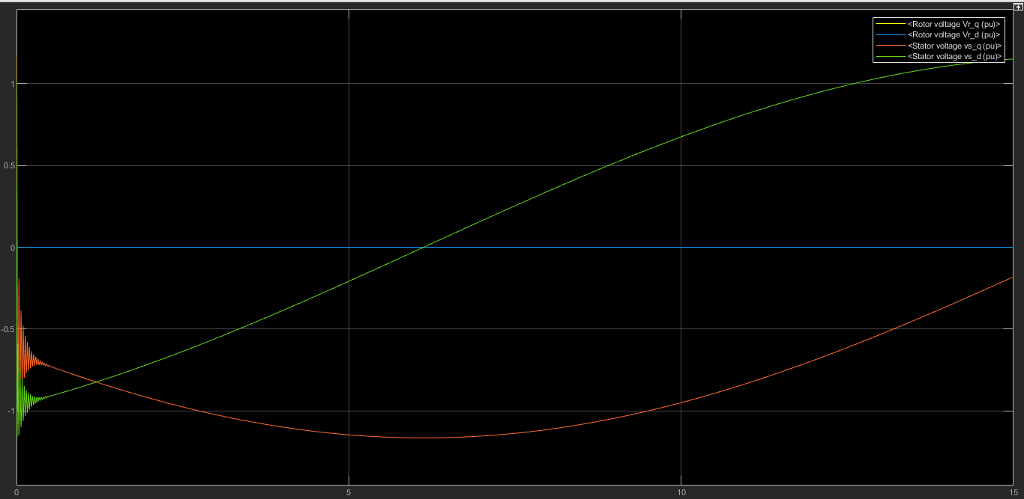
  + The stator voltage first decrease, then increase (vs_q).
  + The stator voltage increases in a curve value (vr_d).
  + The rotor voltage increases perpendicular to x-axis i.e. time (Vr_q)
  + The rotor voltage (Vr_d) remains 0 the whole time because of no load.
* **STATOR CURRENTS:**
  + The stator currents are as:
  + 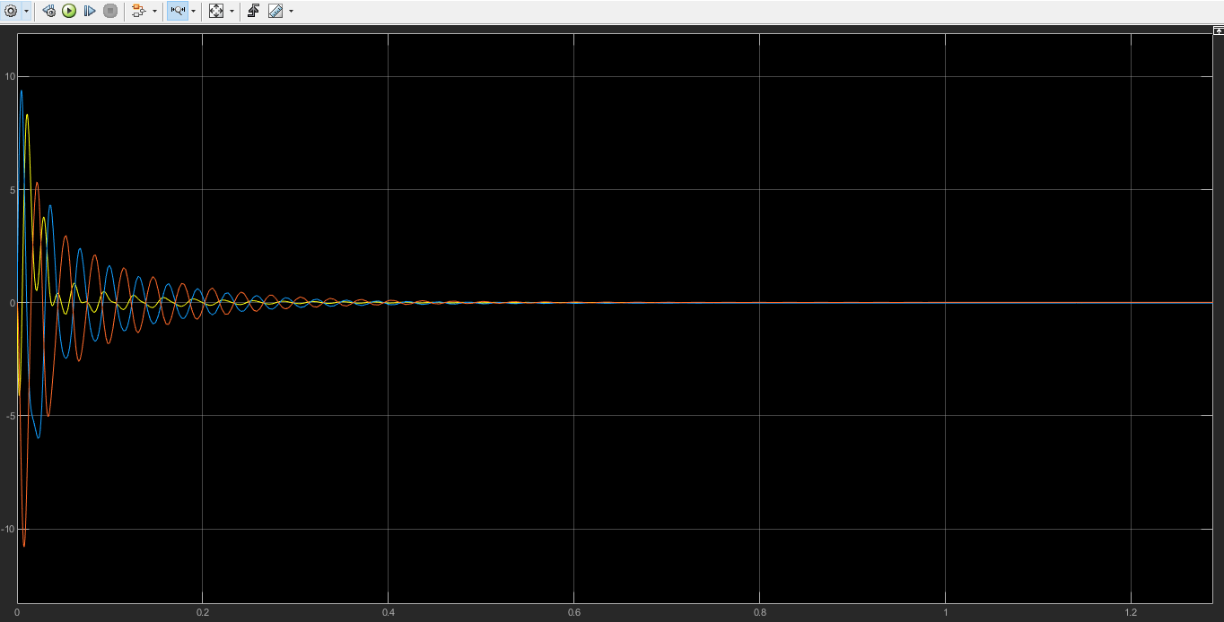
  + The stator currents fluctuate between maximum and minimum amplitudes and when the speed of motor becomes synchronous or it becomes max. constant the stator currents becomes 0.
* **TORQUE AND SPEED:**
  + The torque and speed values at no load are as follows:
  + 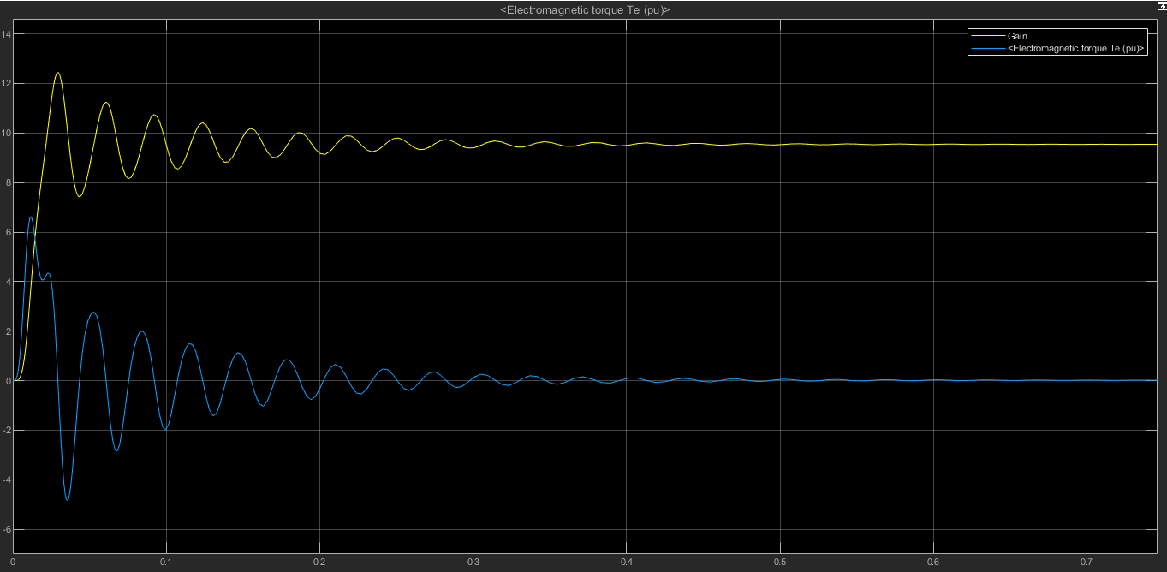
  + The torque of motor at the starting of motor, fluctuates between negative and positive values due to synchronous behavior and it becomes constant i.e. 0 at max. motor speed.
  + The speed of the motor reaches max. at 12wm and it fluctuates between some values due to startup and when stator currents are 0 then the motor speed becomes constant max.
* **POWER FACTOR :**
  + The power factor of induction motors varies with load, typically from around 0.85 or 0.90 at full load to as low as about 0.20 at no-load.
  + At no load, an induction motor draws a large magnetizing current and a small active component to meet the no-load losses.
  + Therefore, the induction motor takes a high no-load current lagging the applied voltage by a large angle. Hence the power factor of an induction motor on no load in low.
* **IM EFFICIENCY:**
  + Efficiency is the power out divided by the power in. Obviously, if there is no load on the motor, the power out and the efficiency are zero.
  + At no-load, the machine draws power from the system because there are still losses in the machine (rotational, core, and some copper). When a load is placed on the shaft of the motor, more power is drawn from the system and the efficiency must go up because the power out is now greater than zero. The efficiency will continue to increase as long as the output power increases faster than the input power.
  + Eventually, however, a point is reached at which the losses begin to grow faster and the efficiency rolls off. It is important to note that the efficiency is fairly flat from around 50% to 100% of rated load and peaks somewhere around 70% to 80%, so specifying a slightly oversized motor does not cause too much of a penalty in efficiency.
  + The efficiency curve of the induction motor is :
  + **GRAPH:**
    - 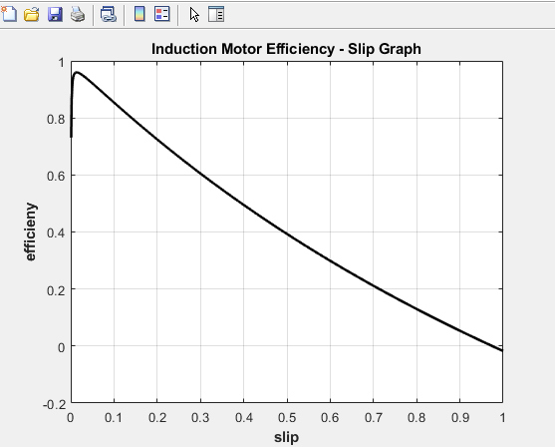
  + The calculation for the efficiency is given by:
    - % M-file create a plot of efficiency-slip of given
    - % induction motor
    - % First, initialize the values needed in this program.
    - clc
    - clear all
    - r1 = 0.103; % Stator resistance
    - x1 = 1.10i; % Stator reactance
    - r2 = 0.225; % Rotor resistance
    - x2 = 1.13i; % Rotor reactance
    - xm = 59.4i; % Magnetization branch reactance
    - v_phase = 460 / sqrt(3); % Phase voltage
    - n_sync = 1800; % Synchronous speed (r/min)
    - w_sync = 188.5; % Synchronous speed (rad/s)
    - s = (0:1:500) / 500; % Slip
    - s(1) = 0.001;
    - nm = (1 - s) * n_sync; % Mechanical speed
    - for ii = 1:501
    - z_s(ii) = r1+(x1); %stator empedance
    - z_r(ii) = (r2/s(ii))+(x2); %rotor empedance
    - z_m(ii) = xm ; %magnetization empedance
    - z_eq(ii) = z_s(ii)+((z_m(ii)*z_r(ii))/(z_m(ii)+z_r(ii))); %eq. empedance
    - i_s(ii) = v_phase/z_eq(ii) ; %stator current
    - p_in(ii) = 3*v_phase*(real(i_s(ii))); %input power
    - e_s(ii) = v_phase-(i_s(ii)*z_s(ii));
    - i_r(ii) = e_s(ii)/z_r(ii); %rotor current
    - p_conv(ii) = 3*(((abs(i_r(ii)))^2)*((r2)*((1-s(ii))/(s(ii)))));
    - p_out(ii) = ((p_conv(ii)))-18-220; %output power
    - eff(ii) = (p_out(ii))/(p_in(ii)); %efficiency
    - end



    - % Plot the Efficiency-Slip curve
    - plot(s,eff,'Color','k','LineWidth',2.0);
    - hold on;
    - xlabel('slip','Fontweight','Bold');
    - ylabel('efficieny','Fontweight','Bold');
    - title ('Induction Motor Efficiency - Slip Graph','Fontweight','Bold');
    - grid on;
    - hold off;
* **CIRCUIT DIAGRAM:**
  + 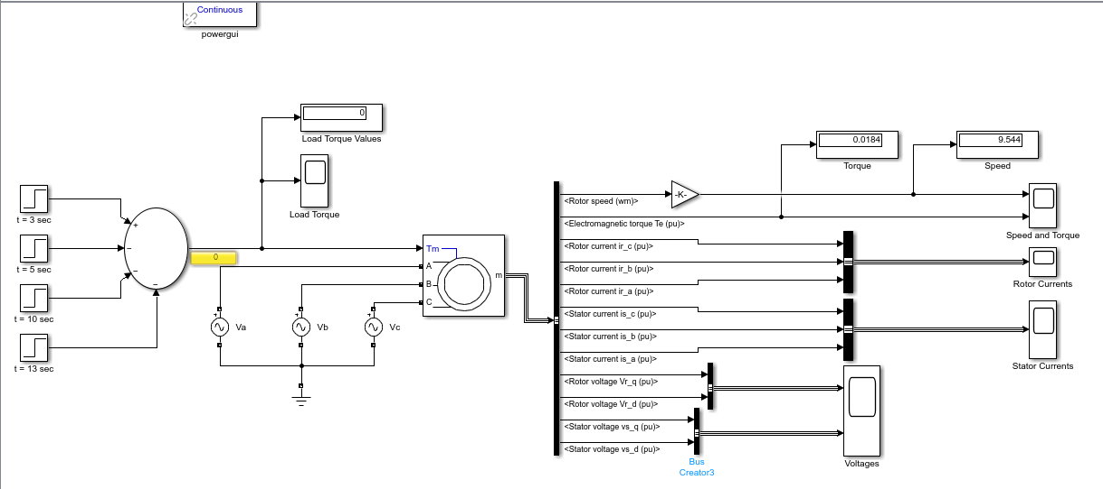
* **LOADING CONDITIONS CURVES:**
  + **LOAD TORQUE:**
    - 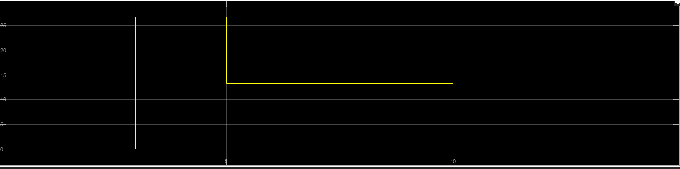
    - The load on the motor increases and then decreases again to no load on the motor.
  + **SPEED AND TORQUE(OUTPUT):**
    - 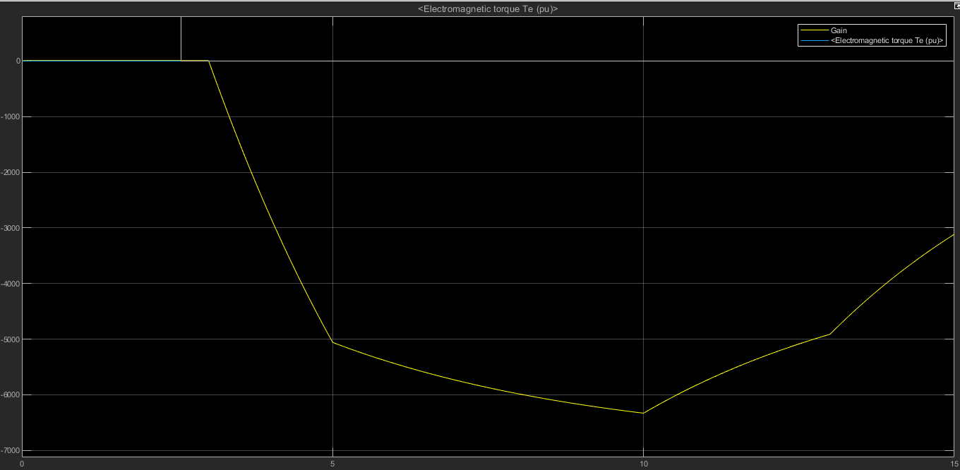
    - As the load on the motor is increased, the speed of motor decreases but as soon as the load again starts to return to its minimum (i.e. no load), the speed of motor again starts increasing.
  + **ROTOR CURRENTS:**
    - 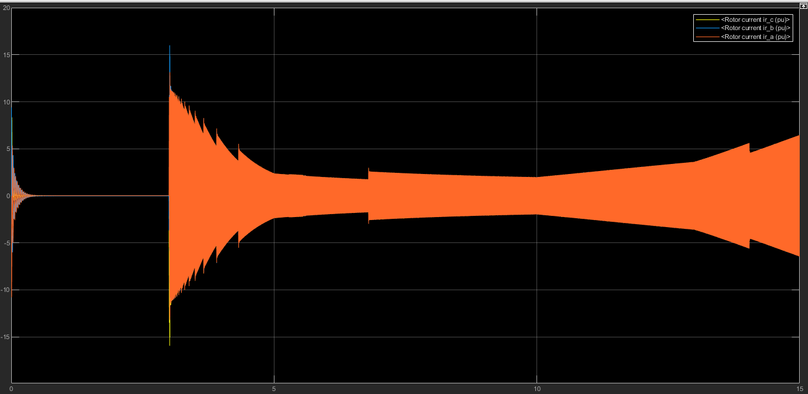
    - When the load on the motor is high, the motor draws more current from the source but as soon as the load is decreased, the current drawn is also decreased.
  + **STATOR CURRENTS:**
    - 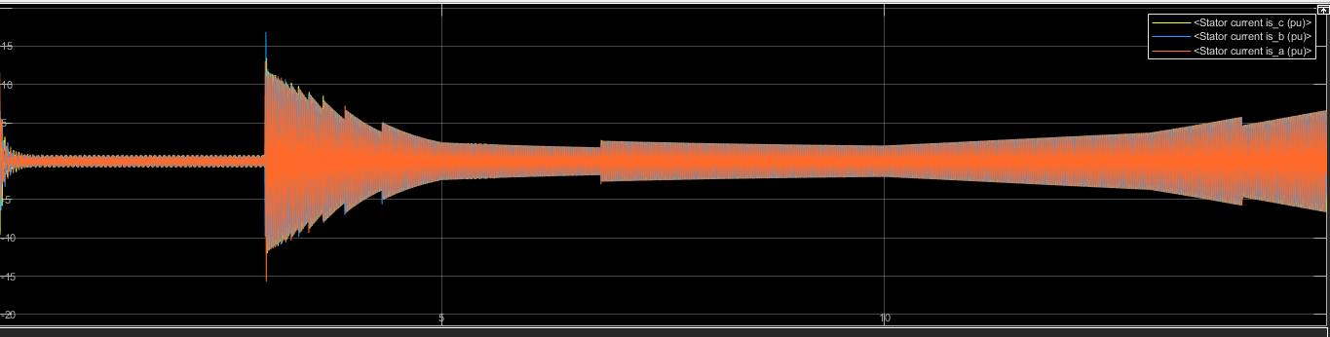
    - Same process happens with the stator currents just like the rotor currents.
  + **TERMINAL VOLTAGES:**
    - 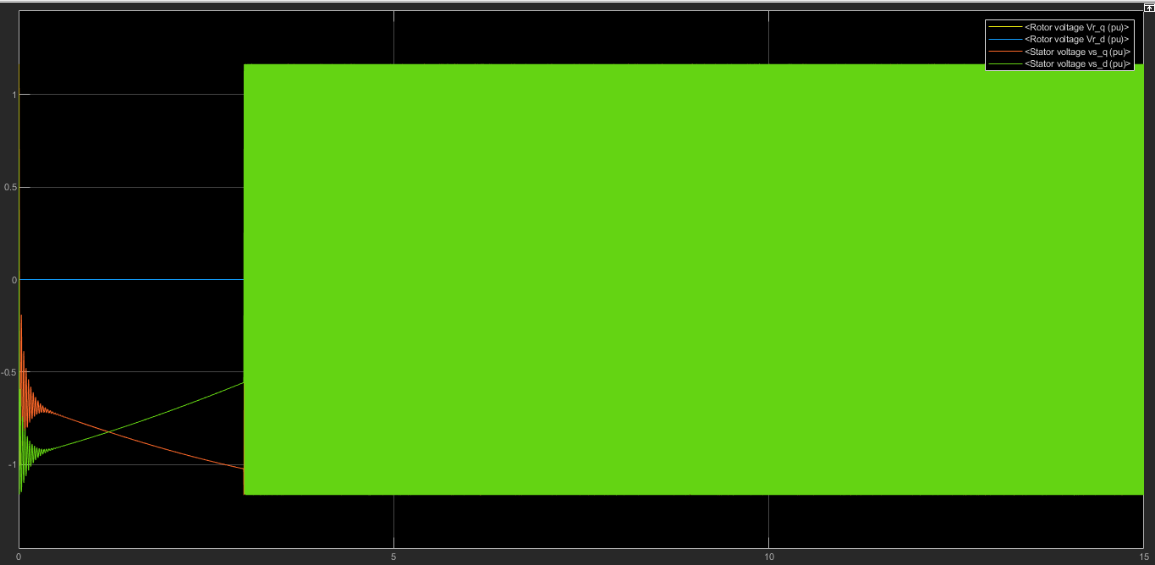
    - The voltages are so high when there is load on the motor as soon as the load becomes zero, the voltage will be minimum again.
  + **DC – TEST:**
    - Basically, the DC voltage is applied to the stator windings of the motor. As the current is DC so there is no induced voltage in the rotor circuit and no resulting rotor current. Also the reactance of motor is zero at DC. So the only quantity limiting current, now in the motor is the stator reactance, and the resistance can be determined.
    - The dc test results are as follows :
    - 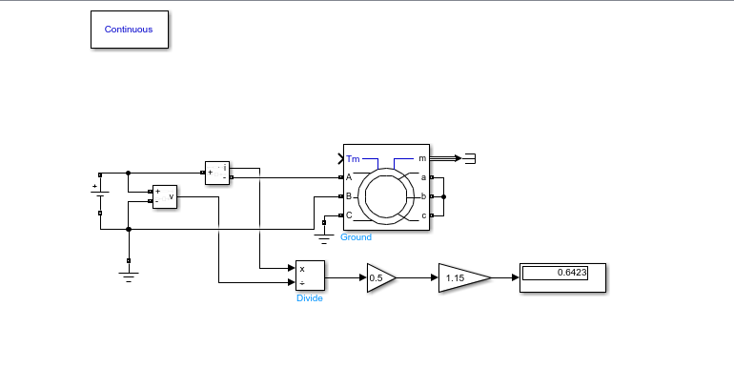
    - In the above results we can see that when a dc voltage is supplied to the rotor of the induction motor, and to find the resistance, we divide V by I to find the resistance of the rotor and is the same value as the resistance of rotor.
  + **BLOCKED ROTOR TEST:**
    - The test is performed by clamping the shaft of the motor so that it cannot turn. The terminals of motor are connected to a 3-phase supply. The rotor of the motor becomes secondary of a transformer operating at the supply frequency. Therefore, the blocked rotor test is similar to the short circuit test on transformer. The rotor is locked to prevent the rotation and balanced voltages are applied to the stator terminals where the rated current is achieved. Under the reduced voltage condition and rated current, core loss and magnetizing component of the current are quite small percent of the total current.
    - 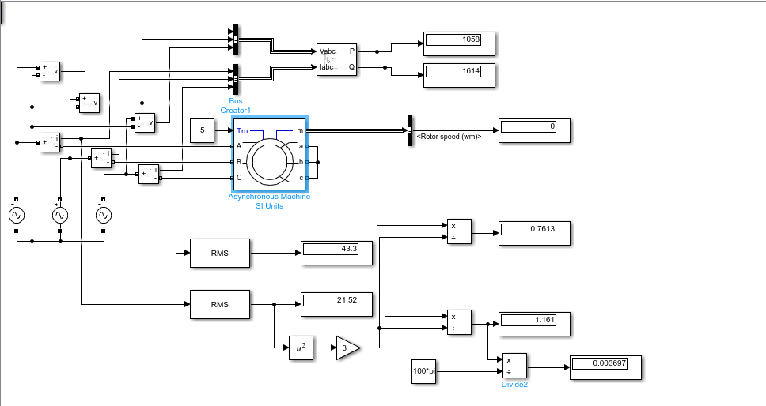
    - The figure shows the speed of motor which is zero i.e. the rotor of the motor is blocked and we can see the power values and terminal voltage and current voltages in the above display values.